Comp Statement Creation
Wednesday, November 5, 2025
- Go to Compensation Home

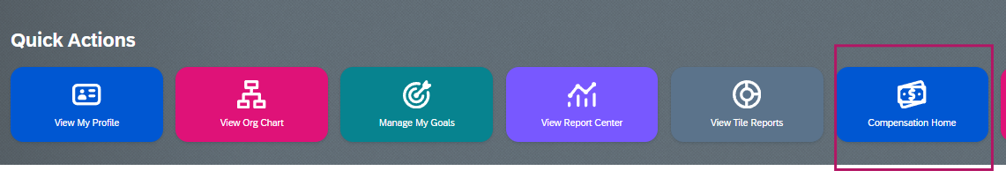

- Select Action for All Plans
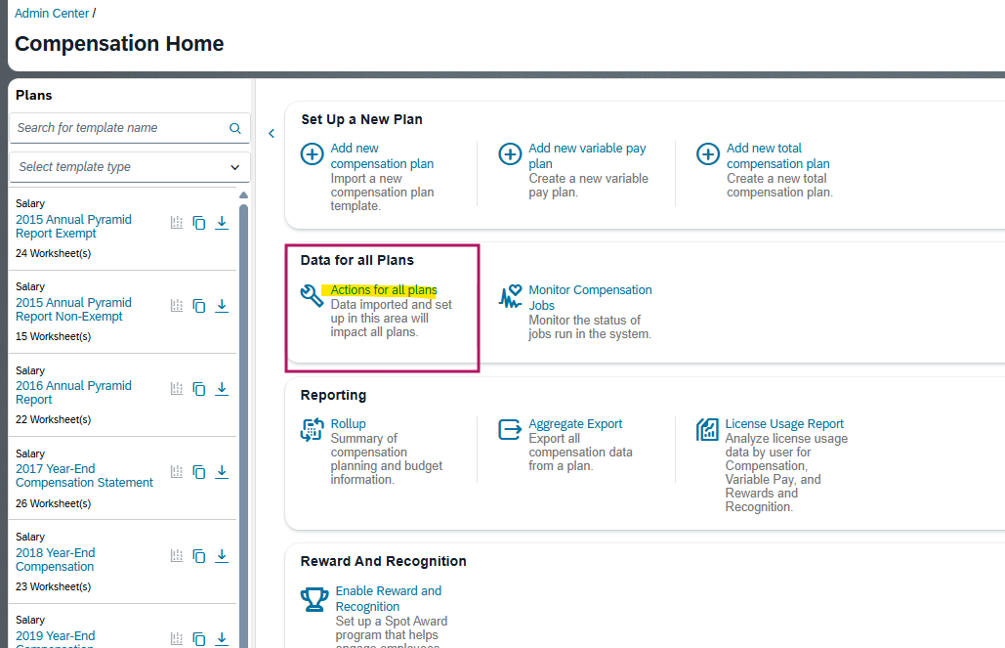

- Manage Statement Templates > Add Template .
- Select the Compensation Statement for the year from the list below
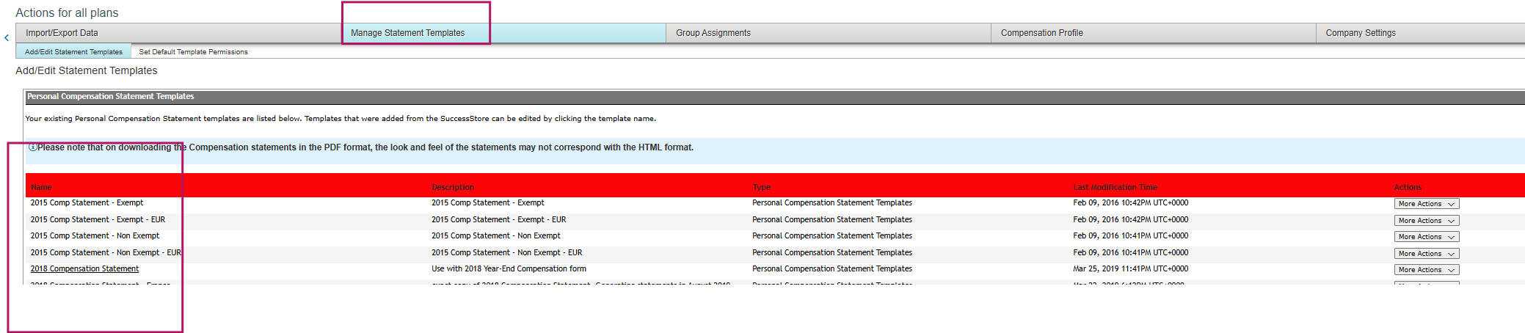

- Save as after renaming
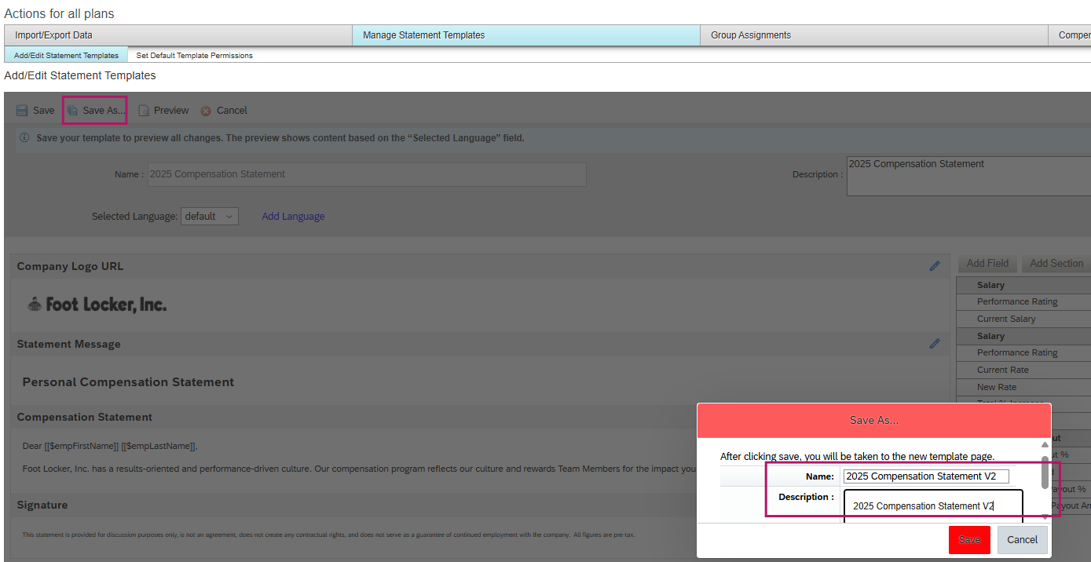
- Delete all the fields and the sections on the RHS
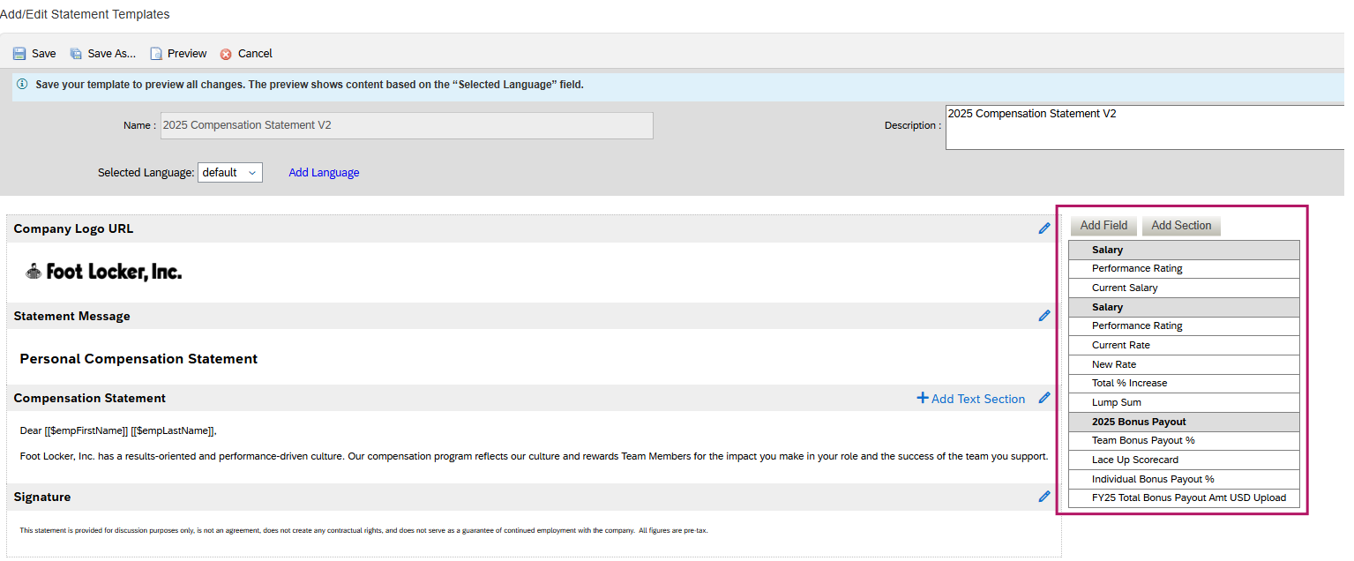
- Based on the 2025 Statement Fields, we will add fields and sections in the system. Grey highlighted ones are the Sections and the non-highlighted ones are the fields. We will create fields from the column 'Label'
- 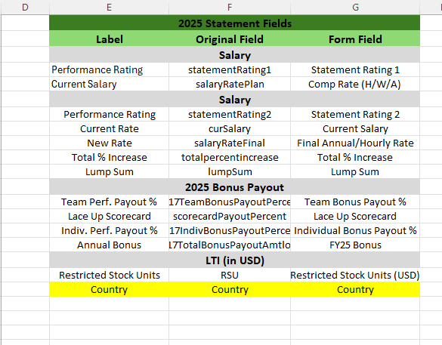

- 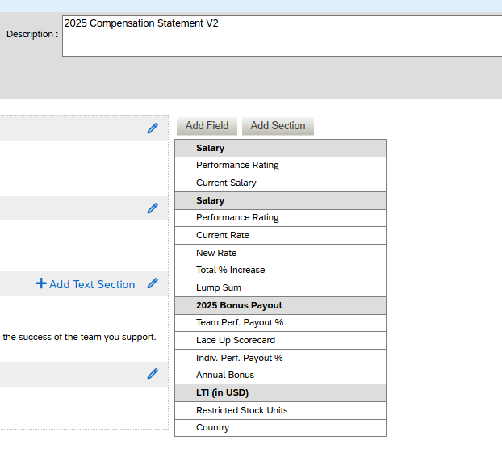
- Add the conditions for the sections and the fields
